# Assignment 3

The original code please see the **assignment3.ipynb**

## Maxpooling2d

Test if the output is the same as the torch layer output.

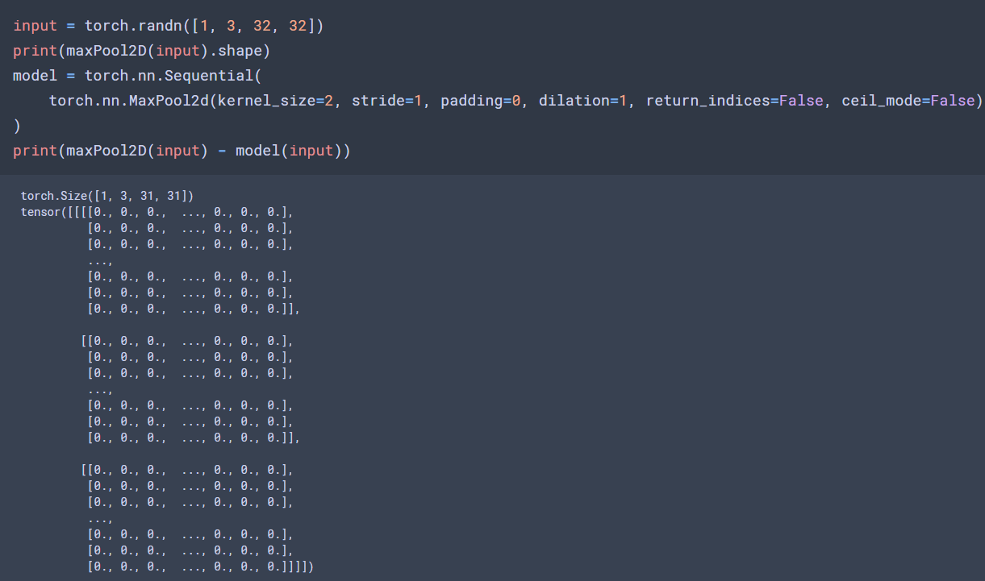

The output and torch output has no difference

## Averagepooling2d

Test if the output is the same as the torch layer output.

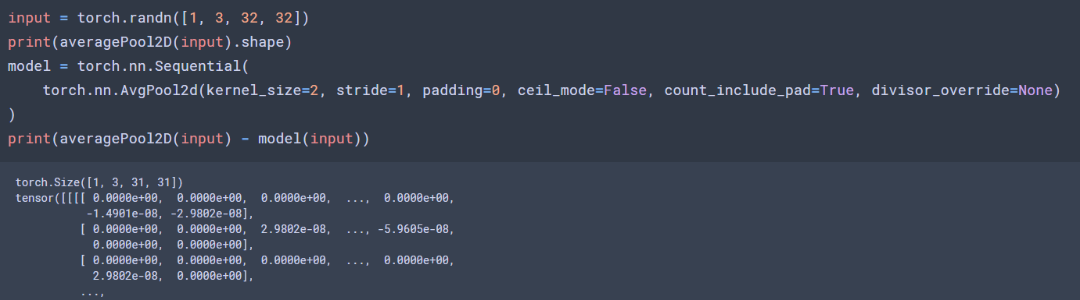

The output and torch output has no difference

## Conv2d

first initial the weight and bias with the given input channel, output channel, height and width. If there is dilation parameter, expand the kernel with 0.

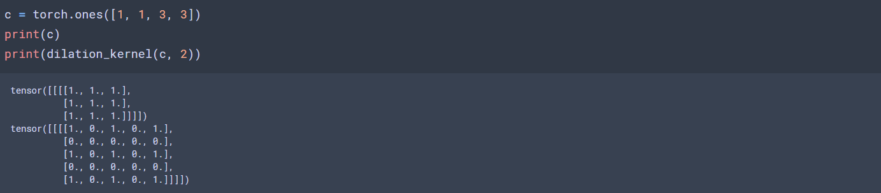

Then apply convolution with input matrix, dilation kernel and stride.

Since in the question there is no padding and group. I didn’t consider these two parameters, but list the algorithm.

Padding: expand the input before convolution.

Group: kernel(N, C, H, W) -> (N / group, C, H, W)

Test if my convolution output is the same as the torch layer output.

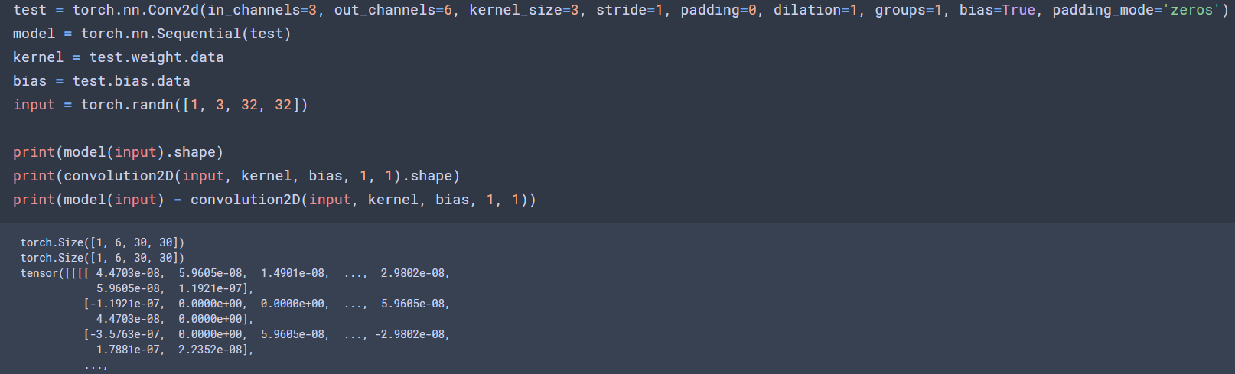

The result is the same as the torch layer output(some decimal point precision problem).

## Flatten & Sigmoid

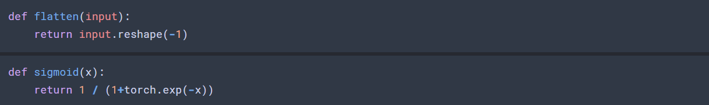

## Cross entropy

First apply softmax

Then apply nn loss:



Test if my cross entropy output is the same as the torch layer output.

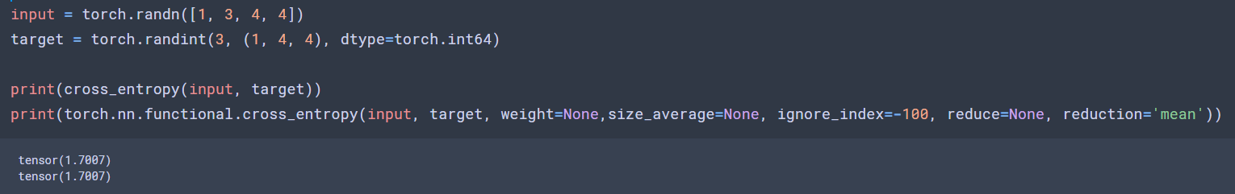

The output is the same.

## Mse loss

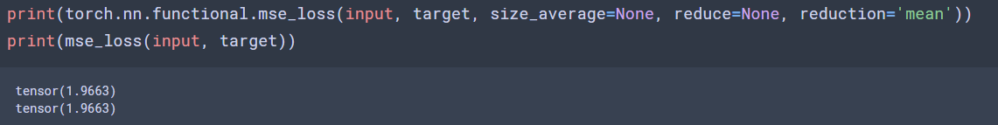

The output is the same